Lab 9 Deliverables

Andrew Han and Dylan Cauwels

# Circuit Diagram

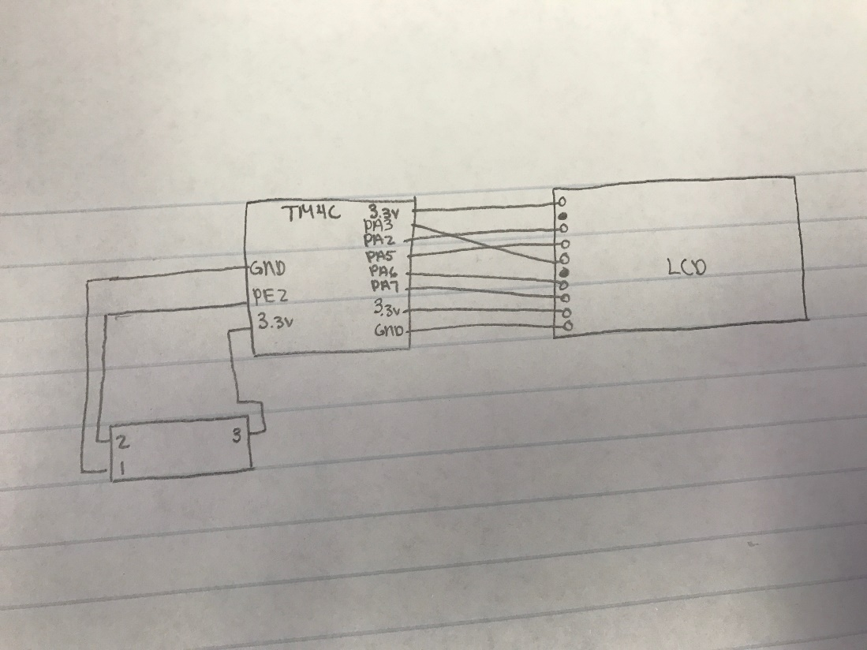

# Oscilloscope Reading

